Subject Heading: CDC- funded surveillance Project PREVENT Invitation

<Institutional Letterhead>

Dear <Institution> Employee,

The <Institution> is partnering with the Centers for Disease Control and Prevention (CDC) to conduct Project PREVENT. **Project PREVENT (PReventing Emerging Infections Through Vaccine EffectiveNess Testing) is evaluating the effectiveness of COVID-19 vaccines and its impact on health care providers. You were recently tested for COVID-19 and may be able to participate in this important project.**

Your participation in this project is voluntary and choosing to participate or not participate will not impact your employment or standing with <Institution>. If you are interested in learning more about the project, please click on this link to **PROJECT PREVENT.**

The link will take you to a screening page to see if you meet the criteria to participate in this project. If you meet the screening criteria then you will be invited into the project and asked to complete four online surveys. **You will be paid $25 by the PREVENT Project Team after completing each of the four surveys for a total of $100.** The checks will be mailed to you by the University of Iowa project coordinating center.

You will not be given any vaccines or other medications as part of this project. Being vaccinated is not a requirement for participating. No information about you has been given to the project team.

The initial results from this project which currently includes over 10,000 U.S. health care workers have been published in the New England Journal of Medicine ( [NEJM Link](https://www.nejm.org/doi/full/10.1056/NEJMoa2106599) )

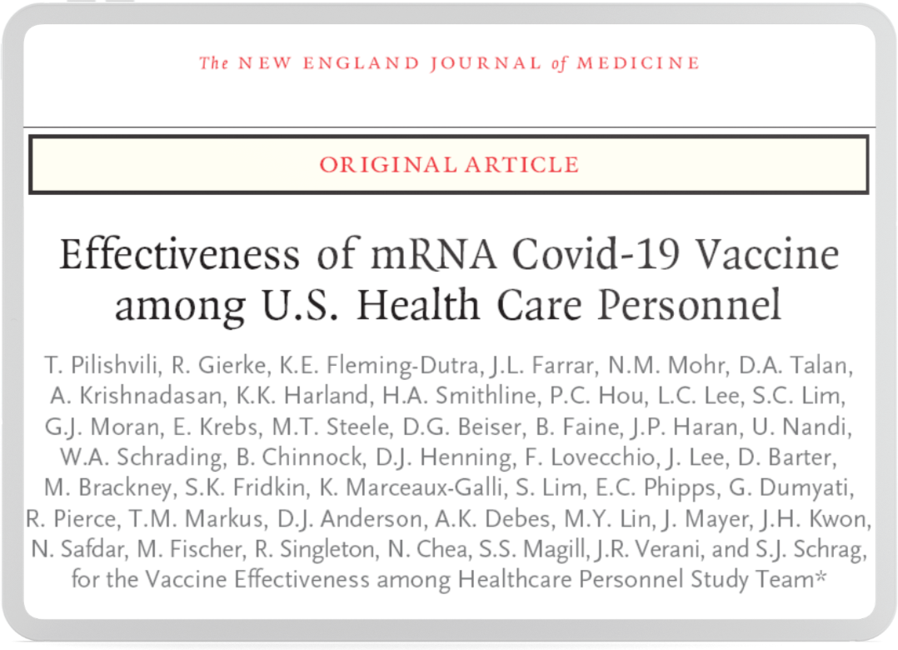

For more information or if you have any questions about the project, please contact the <Institution> project team members at <Insert contact info of site team> or visit www.prevent-project.org. If you would not like to receive any further emails about this project, please click here to **DECLINE**.

Sincerely,

<Site PI name and contact information>